# World Blind Union General Assembly 2025 Obituary

The following tributes honour dedicated leaders and advocates from across the world who advanced the rights, inclusion, and empowerment of blind and partially sighted people. Organized by region, these individuals left an enduring legacy through their leadership, advocacy, and commitment to building a more equitable and inclusive society.

## Africa

**Full name:** Manuel Lopes Rodriguez  
**Country:** Guinea-Bissau  
**Position(s) held:** Founder, AGRICE (Association Guineenne de Réhabilitation et l’Intégration des Aveugles)  
**Tribute:**  
Manuel Lopes Rodriguez (1951–2019) became blind at the age of three. Despite his visual impairment, he became a successful entrepreneur and a tireless advocate for blind and visually impaired people in Guinea-Bissau. In 1996, he founded AGRICE and later created educational and support centers for blind youth, including the Bengala Branca School in 2003. He expanded his mission to include people with multiple disabilities, establishing additional centers in Bafata and Gabu. His lifelong efforts significantly advanced inclusion and accessibility for blind and disabled persons, and in 2015, he was honored with a Nobel Prize for children.

**Full name:** Cathy Donaldson  
**Country:** South Africa  
**Position(s) held:** Not specified  
**Tribute:**  
Cathy Donaldson’s life and work were celebrated with memorial services held in February 2025, reflecting her significant contributions to the blind community in South Africa. Her dedication and influence inspired colleagues and stakeholders alike. She is remembered for her commitment, leadership, and impact on the lives of visually impaired individuals.

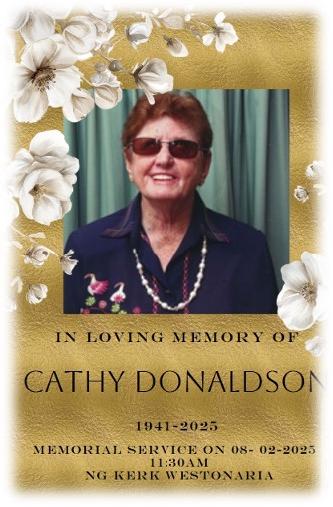

**Full name:** Jean Benoit Reynolds Permal  
**Country:** Mauritius  
**Position(s) held:** Founder/Director, Lizie Dan La Main, Union Des Aveugles de l’Ile Maurice  
**Tribute:**  
Jean Benoit Reynolds Permal (1947–2025) devoted over 42 years to advancing the rights of visually impaired people in Mauritius. His commitment, generosity, and leadership transformed lives across education, independence, and advocacy. Through his vision, he created spaces of solidarity and progress for generations of blind and partially sighted individuals. His legacy continues to inspire efforts toward a more inclusive, equitable, and accessible world.

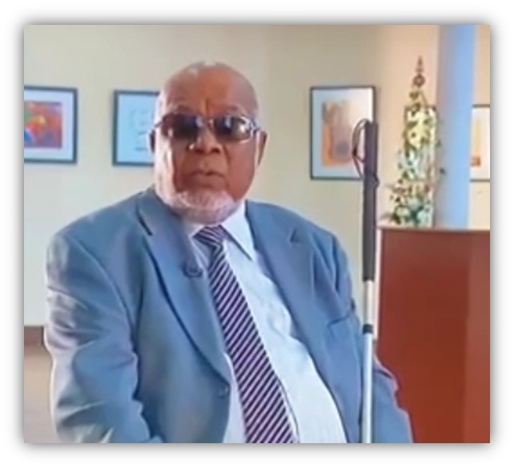

**Full name:** Barr. Danlami Umaru Basharu  
**Country:** Nigeria  
**Position(s) held:** Member and Former Chairman, UN CRPD Committee; Leader, Anglo-Nigerian Welfare Association for the Blind (ANWAB)  
**Tribute:**  
Barrister Danlami Umaru Basharu, MON, was a visionary Nigerian lawyer, broadcaster, and disability-rights leader. Educated at Cambridge, Harvard, Durham, and the Nigerian Law School, he championed inclusion nationally and internationally, leading the UN Committee on the Rights of Persons with Disabilities and the Anglo-Nigerian Welfare Association for the Blind. His tireless advocacy changed lives, and his warm personality and dedication made him deeply cherished in his community. He passed away in June 2023, leaving a lasting legacy of courage, service, and empowerment.

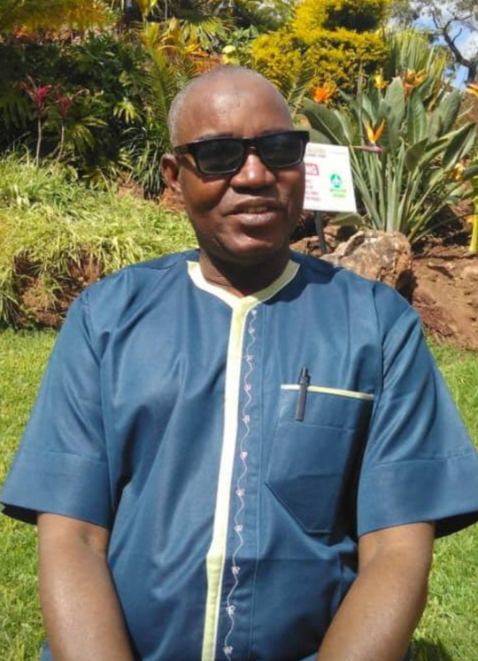

## Asia

**Full name:** Sasada Saburo  
**Country:** Japan  
**Position(s) held:** Instructor of Medical Massage Training Project  
**Tribute:**  
Sasada Saburo (1947–2021) was a Japanese educator and massage therapy specialist who lost his sight in both eyes in a laboratory accident during university. He taught therapeutic massage at the National Rehabilitation Center for Persons with Disabilities and later served as a JICA Senior Volunteer, providing training for blind massage practitioners in several Asian countries. Sasada conducted comparative research on massage techniques across Asia and Europe, promoting the profession as a suitable and sustainable career for blind persons. In recognition of his contributions, he was awarded an Honorary Doctorate in Sri Lanka in 2020. His lifelong dedication significantly advanced education and employment opportunities for blind people both in Japan and Asian countries.

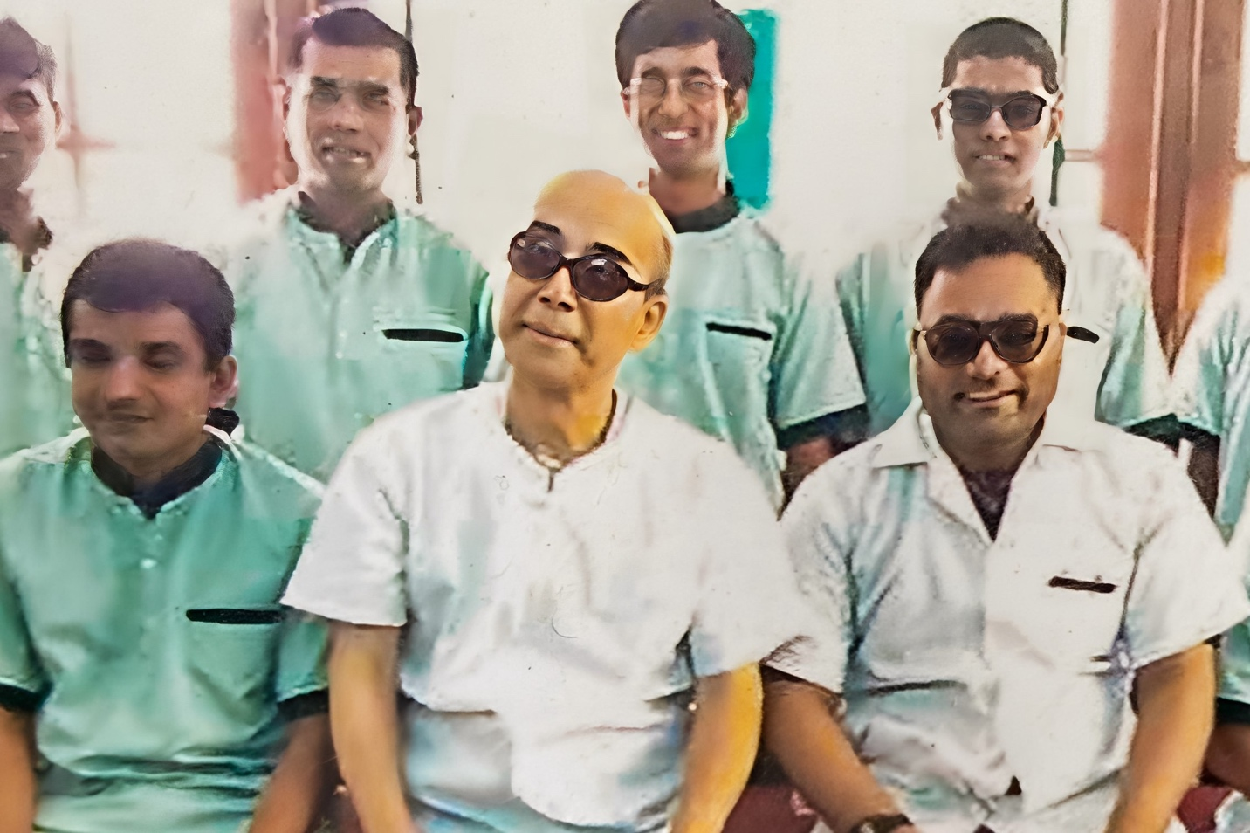

**Full name:** Iwahashi Akiko  
**Country:** Japan  
**Position(s) held:** Former Board Member, National Committee of Welfare for the Blind in Japan  
**Tribute:**  
Iwahashi Akiko (1929–2019), together with her husband Iwahashi Hideyuki (1925–1984), who served as Vice President of the World Council of Welfare for the Blind for 20 years, made significant contributions to the welfare of blind people in Japan and worldwide. After her husband’s passing in 1984, she became President of Nippon Lighthouse for the Blind, where she led its management and actively participated in international conferences as a member of the newly established WBU Committee on Rehabilitation and Employment. In recognition of her lifelong service, she was elected an Honorary Life Member of the World Blind Union in 2012, received the Helen Keller-Sullivan Award from the Tokyo Helen Keller Association in 2012, and was honored with the Prime Minister’s Commendation of Japan in 2015.

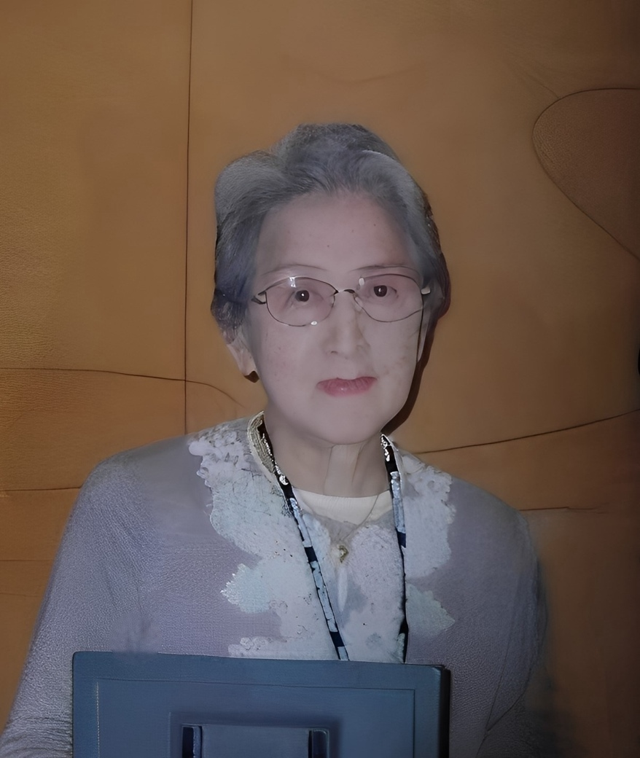

**Full name:** Mr. Nar Bahadur Limbu  
**Country:** Nepal  
**Position(s) held:** Director, Nepal Association of the Blind (NAB)  
**Tribute:**  
Mr. Nar Bahadur Limbu dedicated over 25 years to advancing the rights, education, and inclusion of blind and visually impaired people in Nepal. As a visionary leader of the Nepal Association of the Blind—serving as President (1998–2014), Executive Advisor (2014–2016), and Director (2016–January 2024)—he played a key role in shaping disability-inclusive policies and spearheaded landmark achievements such as 5% job reservations, free education for the blind, and government recognition of Braille. His tireless efforts in policy reform, institution-building, and international advocacy transformed countless lives and amplified the voice of the blind community on the global stage. He leaves behind a lasting legacy of dignity, empowerment, and hope that will continue to inspire generations.

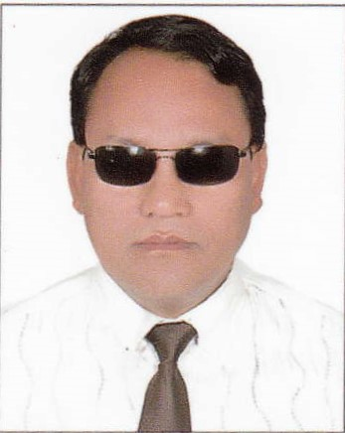

**Full name:** Md Nurul Alam Siddique  
**Country:** Bangladesh  
**Position(s) held:** Former President, National Federation of the Visually Impaired (NFVI)  
**Tribute:**  
Md Nurul Alam Siddique (1960–2025) was a dedicated advocate for visually impaired people in Bangladesh. As the former president of the National Federation of the Visually Impaired (NFVI), he worked tirelessly to improve the lives of blind individuals through advocacy, education, and support programs. Despite his own blindness, he led the organization with vision and compassion, leaving a lasting impact on the visually impaired community in Bangladesh. His leadership strengthened NFVI and inspired many to continue his mission of empowerment and inclusion.

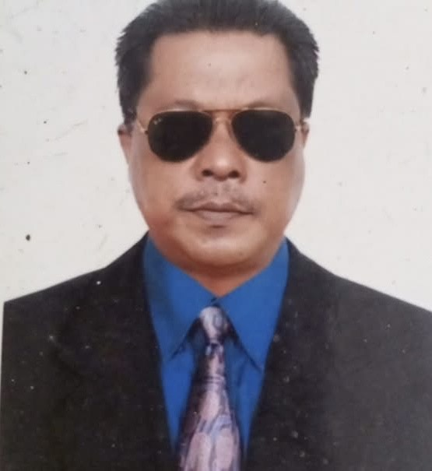

**Full name:** Senator Monthian Buntan  
**Country:** Thailand  
**Position(s) held:** Former President, Thailand Association of the Blind; Former Member, UN CRPD Committee; Thai Senator  
**Tribute:**  
Senator Monthian Buntan (1965–2024) was a visionary leader and lifelong advocate for the rights of persons with disabilities, extending his influence from Thailand to the global stage. Blind from birth, he overcame immense barriers to become a parliamentarian, a two-term member of the UN Committee on the Rights of Persons with Disabilities, and a driving force behind disability-inclusive laws and policies in Thailand. His work in education, accessible technology, and inclusive governance empowered countless individuals. He is remembered for his motto, “I’ve given up on giving up,” reflecting his determination and resilience.

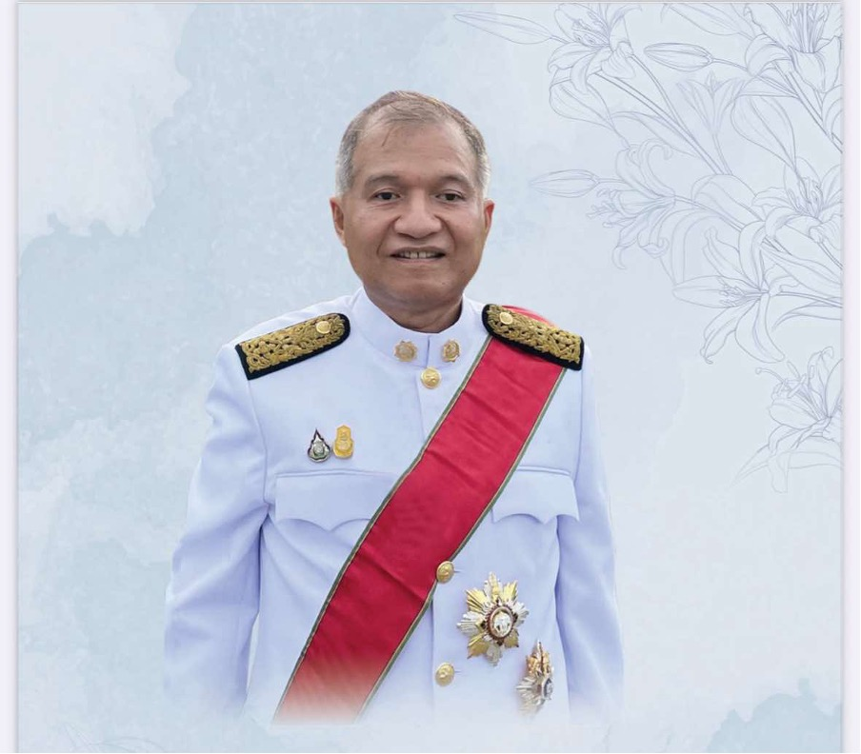

## Europe

**Full name:** Rodolfo Cattani  
**Country:** Italy  
**Position(s) held:** Vice-President, World Blind Union (1992–1996); Founding Figure and President, European Blind Union (2019–2022)  
**Tribute:**  
Rodolfo Cattani (1941–2022) dedicated his life to achieving an equal and inclusive world. As a leading advocate for the rights of blind and partially sighted people, he served in key roles across national and international disability organizations. He was Vice President of the Italian Union of the Blind and Partially Sighted for 12 years, Director of International Relations, President of the Italian Disability Forum (2014–2017), and Secretary-General of the European Disability Forum (2009–2017). Renowned for his intelligence, culture, and integrity, he advanced policies for accessibility and inclusion while providing support to vulnerable populations worldwide. His commitment and leadership left a lasting impact on the global disability movement.

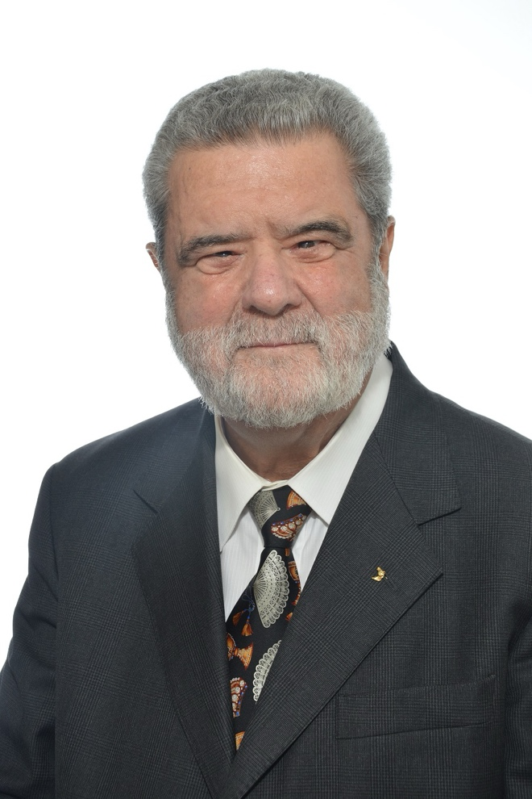

**Full name:** Alexander Neumyvakin  
**Country:** Russia  
**Position(s) held:** President, All-Russian Society of the Blind (VOS); President, Russian Paralympic Committee  
**Tribute:**  
Alexander Yakovlevich Neumyvakin (1940–2021) was a tireless advocate for the rights and dignity of people with disabilities. After losing his sight, he dedicated himself to public service, becoming President of VOS in 1986 and later leading the Russian Paralympic Committee. For over three decades, he represented and empowered more than 200,000 blind and partially sighted citizens of Russia, championing education, employment, and social inclusion. His influence extended globally through his leadership in the European Blind Union and the World Blind Union. A skilled parliamentarian and international representative, he shaped laws and policies that advanced equality and social protection.

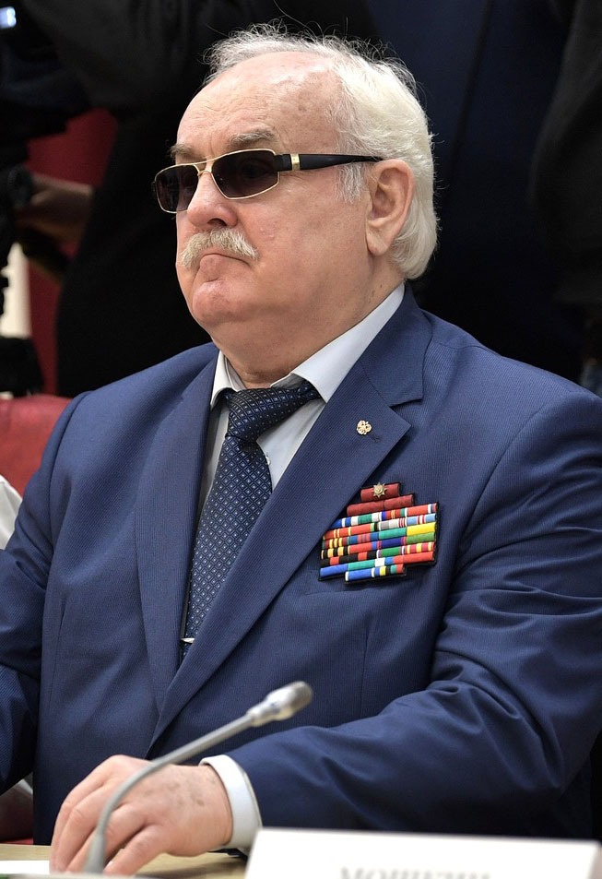

**Full name:** Maria Kyriacou  
**Country:** Cyprus  
**Position(s) held:** Vice President, Pancyprian Organization of the Blind; Secretary General, European Blind Union (2015–2021); National Representative, ICEVI  
**Tribute:**  
Maria Kyriacou (1972–2021) was a passionate advocate for blind and visually impaired people, with a particular focus on children and women. As an educator for over 20 years, she inspired countless students, while her leadership roles at the Pancyprian Organization of the Blind and ICEVI amplified her impact nationally and internationally. From 2015 to 2021, she served as Secretary General of the European Blind Union, tirelessly promoting inclusion and accessibility. Maria’s competence, warmth, and dedication left a lasting impression on all who worked with her. Her legacy continues to inspire the disability rights community.

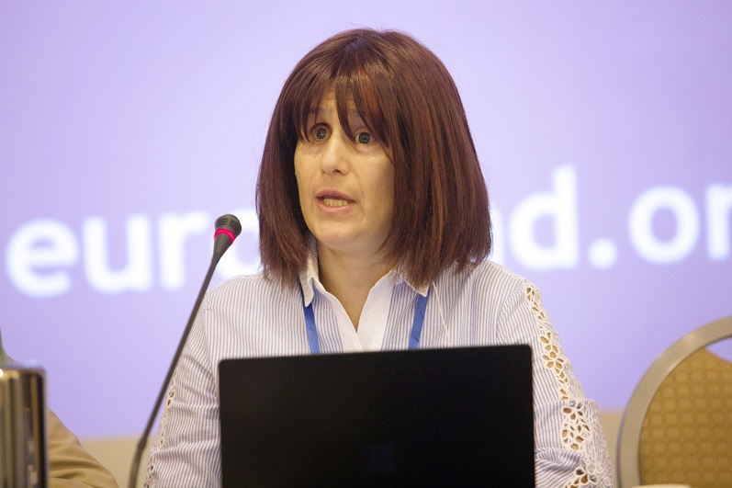

## Americas

**Full name:** Scott C. LaBarre  
**Country:** United States  
**Position(s) held:** General Counsel for National Federation of the Blind  
**Tribute:**  
Scott C. LaBarre was a visionary leader whose work profoundly advanced cross-border access to published works through his instrumental role in the Marrakesh Treaty. As president of both the NFB of Colorado and the National Association of Blind Lawyers, he combined legal expertise with advocacy to change international copyright norms. His dedication opened doors to accessible reading materials for blind people worldwide, laying the groundwork for a more inclusive global literary landscape. He provided strategic expertise to the World Blind Union during the fight for the Marrakesh Treaty and with worldwide implementation. He is well known for his legal work in civil rights and in increasing opportunities for potential blind lawyers. The world lost a dynamic and charismatic leader on December 10, 2022.

Photo of Scott C. LaBarre


**Full name:** Oral O. Miller  
**Country:** United States  
**Position(s) held:** Fourth President, American Council of the Blind; Former National Representative/Executive Director, ACB; Second President, United States Association of Blind Athletes  
**Tribute:**  
Oral O. Miller (1933–2023) was a dedicated advocate for blind athletes and the broader blind community. He developed a passion for sports early in life and continued promoting athletic participation for visually impaired people through the United States Association of Blind Athletes and the International Blind Sports Association. He played a key role in merging the World Council for the Welfare of the Blind and the International Federation of the Blind, creating the World Blind Union. Miller’s leadership and dedication to inclusion left an enduring mark on both national and international communities.

**Full name:** Juan Cancio Valdés Juíz  
**Country:** Cuba  
**Position(s) held:** First President, Centro Nacional de Rehabilitación para Personas Ciegas de Cuba  
**Tribute:**  
Juan Cancio Valdés Juíz graduated in 1969 from the “Karl Marx” Institute in East Germany with a specialization in physiotherapy. He served as Director of National Physiotherapy at the Ministry of Public Health and assisted Dr. Rodrigo Álvarez Cambras in rehabilitating prominent figures nationally and internationally. He became the first President of the National Rehabilitation Center for Blind People in Cuba, also leading the Department of Rehabilitation and Sports. His contributions strengthened rehabilitation and education for blind individuals across the nation.

